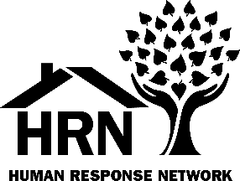
P.O. Box 2370/111 Mountain View St.
Weaverville, CA 96093
(530) 623-2024/FAX 623-6343
www.hrntrinity.org
E-mail: hrn@hrntrinity.org

INCOME TAX ASSISTANCE (VITA) VOLUNTEER

Our Mission: HRN provides advocacy, education, and programs that promote personal empowerment, support vulnerable populations, and create connections to local resources.

DESCRIPTION OF DUTIES
Duties:
- Meet individually with clients, interview clients, review tax documents, and prepare returns using professional tax software.
- Connect clients to meaningful savings opportunities including U.S. Savings Bonds and credit union accounts.

Qualifications:
- Must successfully complete free tax preparation training and pass IRS certification test.
- Must maintain client confidentiality.
- Ability to build rapport & discuss sensitive financial information with care.
- No prior tax experience is required, but the ability to prepare a basic tax return or other relevant classroom or work experience in tax law or accounting is recommended.

Time Requirement:
- A minimum of one 4-6-hour shift, one to two weekdays (Monday – Friday) per week during tax season (January 25th to April 18th).
- Our greatest need is during February and early March when our tax site is the busiest.

Training:
- Tax Volunteers are required to attend a pre-season orientation and complete the training.
- Training is online through IRS’s Link and Learn system, which can be done at HRN with one-on-one mentoring and assistance.
- Both new and returning Tax Volunteers must pass the IRS certification exam.

Benefits:
- Gain professional skills while helping families in Trinity County boost their financial stability!
- Free tax law and tax preparation training, culminating in IRS certification
- Support from trained Vita Volunteers and staff with 19+ years’ experience

Contact: Jeanetta Trounday, Site Coordinator, at jtrounday@hrntrinity.org or (530) 623-2024

